Chapter 1 – Loading and Shaping data
Understanding Databricks notebooks
Your team is migrating from legacy on-premises SQL servers to Databricks, and your manager asks you to explain to stakeholders what makes Databricks notebooks different from traditional SQL scripts. They want a clear, simple explanation for the upcoming kickoff meeting.
Which statement best describes how a Databricks notebook operates? R: Independent cells that run SQL or Python and display results in line

Loading your first dataset
You're a data engineer at Global Retail Analytics, an e-commerce consulting firm. Your Databricks workspace is already set up - the online_retail.csv file is stored in the datasets volume under the default schema, and all exercise notebooks are in the Exercises folder in the Workspace.
Start by exploring the catalog to find your data, then load it into a Spark DataFrame and inspect its structure.
- Navigate to your databricks_ws_*** catalog and copy the path for online_retail.csv from the datasets volume.
- Open the ex_1_1 notebook from the Exercises folder in the Workspace
- Complete the code to load the CSV and display its schema.
- Based on the schema output, what is the data type of the UnitPrice column? R: double

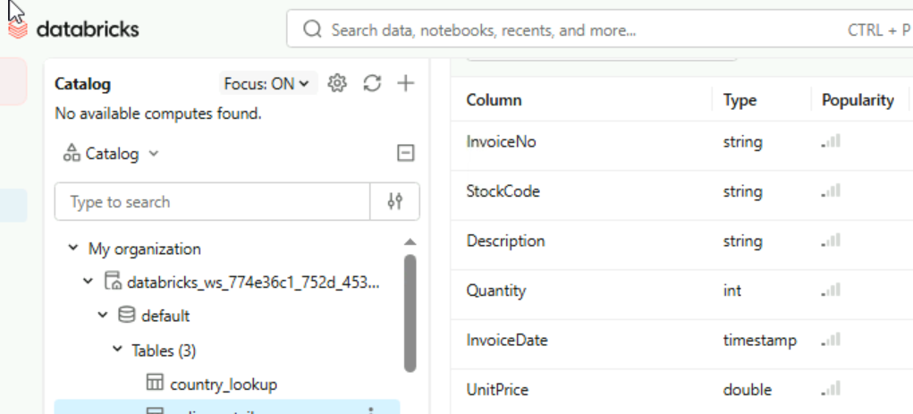

Exploring driver logs
Now that you've loaded the CSV from the datasets volume, let's continue working with the online_retail dataset. Before diving into transformations, you need to preview the data and learn how to debug when things go wrong.
In this exercise, you'll load the dataset, display sample rows, and explore the driver logs - your go-to resource when troubleshooting Spark jobs.
- Open the ex_1_2 notebook and replace the volume path with your catalog name.
- Complete the code to show the first 10 rows.
- Open the driver logs by accessing the compute menu in the notebook toolbar.
- Which of the following files does NOT appear in the driver logs? R:
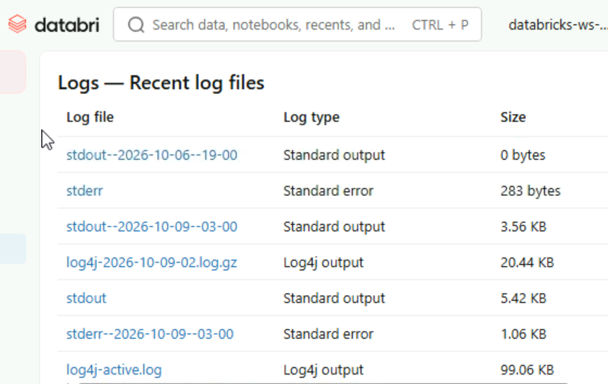

Using PySpark to shape data
Let's get back to our online_retail dataset. Your French sales team has flagged unusual bulk orders and wants you to investigate high-quantity purchases from France.
In this exercise, you'll select specific columns, filter rows using multiple conditions, and use the interactive display to explore the results.
- Open the ex_1_3 notebook and replace the volume path with your catalog name.
- Complete the code to select the specified columns including Description.
- Complete the filter to keep only rows where Quantity is greater than 20 AND Country is France.
- Display the filtered results and use the interactive table to answer the following question.
- In invoice 536998, what was the quantity ordered? R: 58

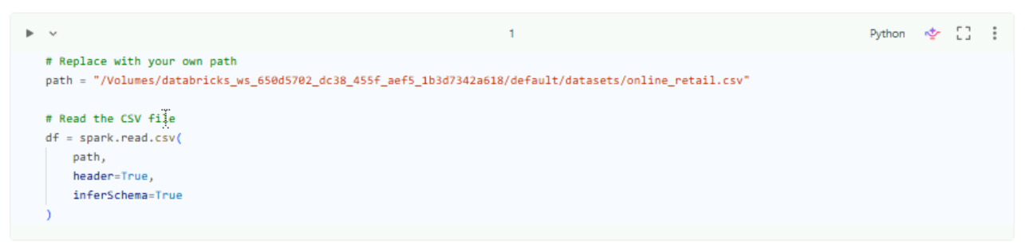
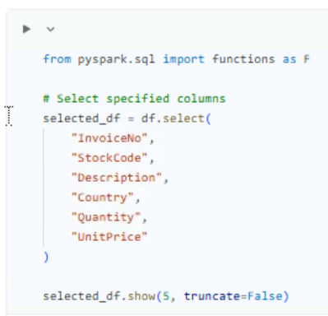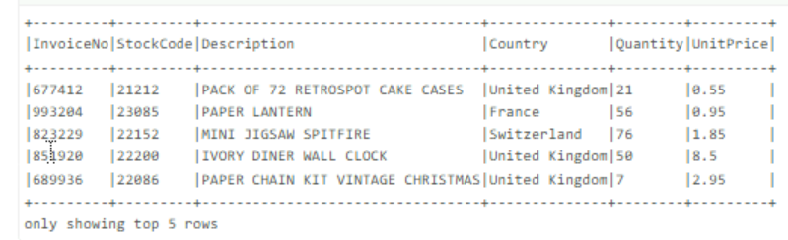
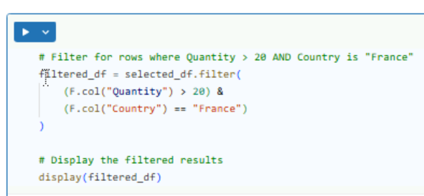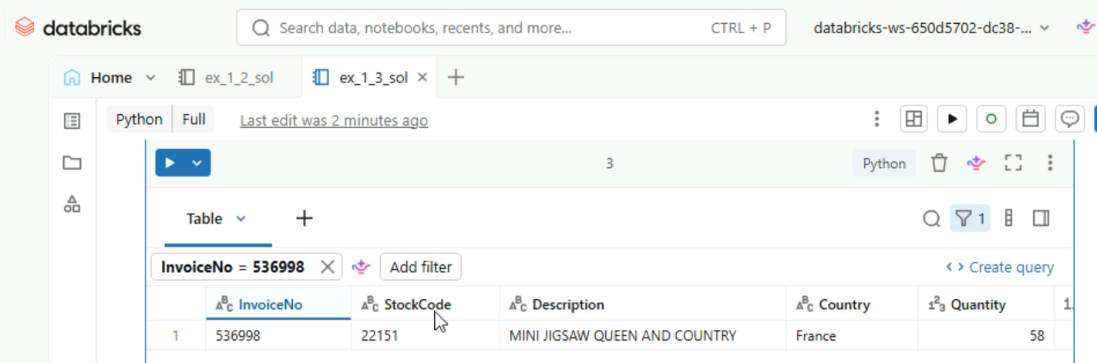
Analyzing data with SQL
Continuing with our online_retail dataset, your manager wants to understand cancellation patterns across different countries. Since SQL is often more readable for aggregations and grouping, you'll query the data using SQL and inspect the execution plan to verify how Spark processes your query.
In this exercise, you'll create a temporary view from a filtered DataFrame, run a SQL aggregation, and examine the query plan.
- Open the ex_1_4 notebook and replace the volume path with your catalog name.
- Complete the code to create a temporary view called sales.
- In cell 3, complete the SQL query by filling in the view name in the FROM clause.
- In cell 4, use the right keyword to display the execution plan.
- What filter condition appears in the DataFilters section of the execution plan? R:StartsWith(InvoiceNo, c)

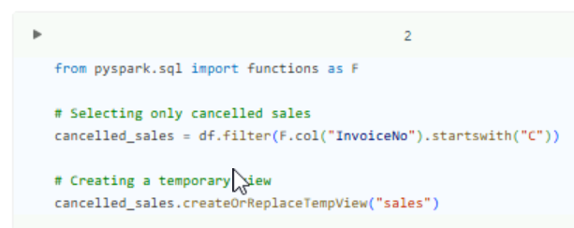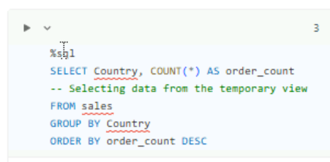
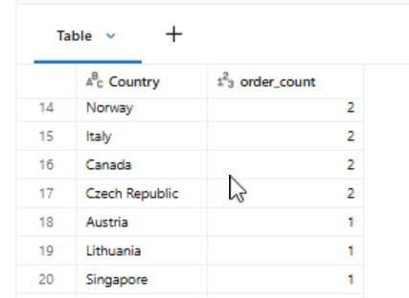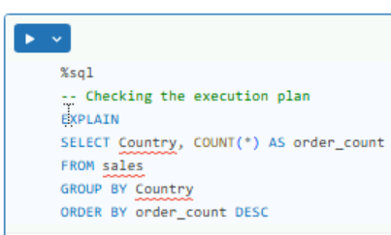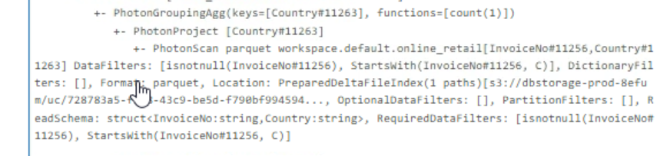

Understanding temporary views
A data engineer on your team loads a DataFrame containing filtered retail transactions and calls createOrReplaceTempView("retail_filtered"). The next day, a colleague opens a new notebook session and tries to query the view, but gets the error shown on the image.
Which of the following best explains why the view is unavailable? R:
The view was session-scoped and disappeared when the original Spark session ended.
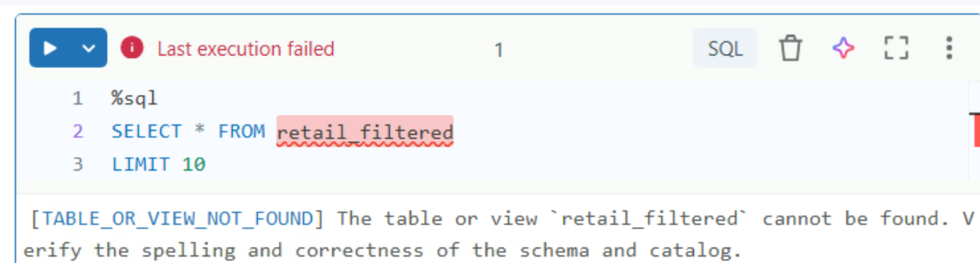

Chapter 2 – Data cleaning and optimization
Why explicit schemas matter
You and a colleague at Global Retail Analytics both load customer_orders.csv and run the same cleaning pipeline, but get different results. The image shows both approaches side by side.
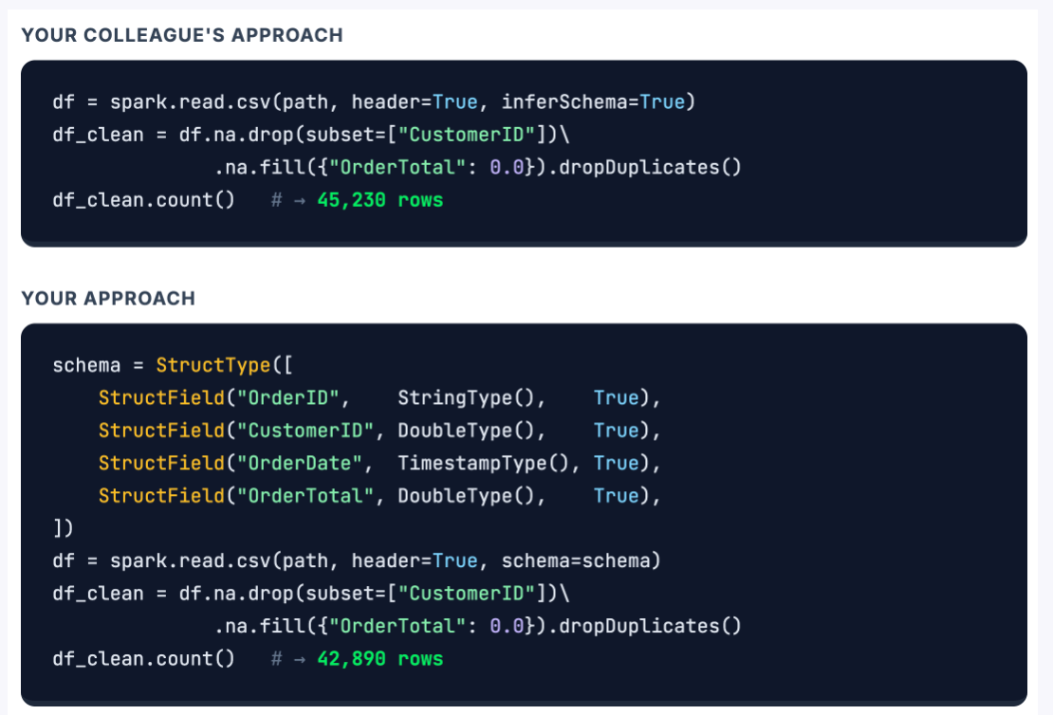
What is the most likely cause of the row count discrepancy? R:
Spark guessed the wrong column types, so the cleaning pipeline couldn't correctly identify and remove invalid values.

Cleaning the online retail dataset
You're a data engineer at Global Retail Analytics. Your manager has flagged quality issues in the online_retail dataset - missing customer IDs, duplicated rows, and cancelled orders are skewing weekly reports.
Before any analysis can begin, you need to define an explicit schema, diagnose the data quality problems, and build a cleaning pipeline that removes invalid records.
- Open the ex_2_1 notebook and replace the volume path with your catalog name.
- Define the schema with StructType and load the CSV into a DataFrame.
- Run the data quality checks to count nulls, duplicates, and invalid rows.
- Build the cleaning pipeline: handle nulls, remove duplicates, and filter out invalid records.
- How many rows remain after the full cleaning pipeline? R: 80,403
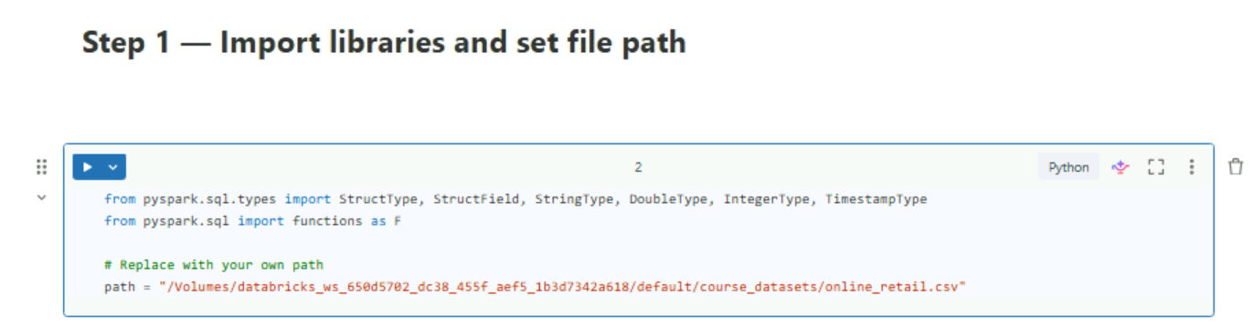
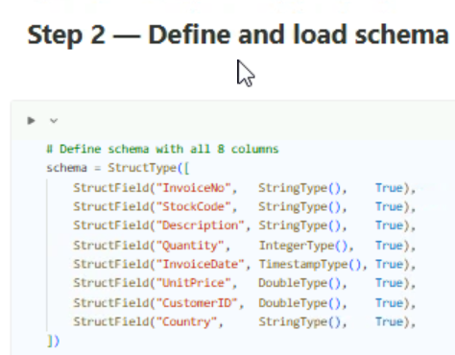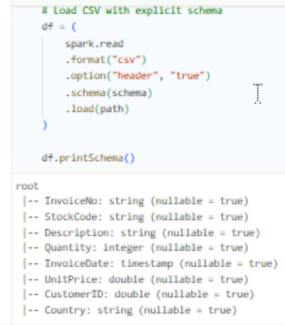
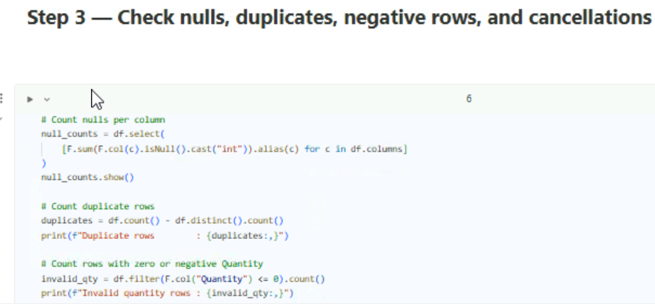
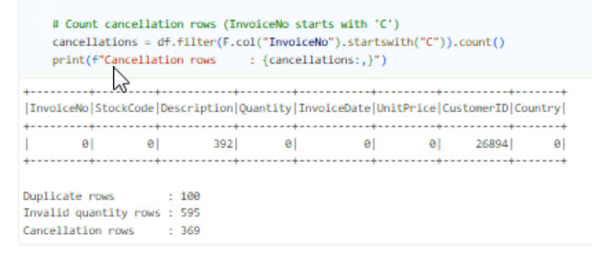
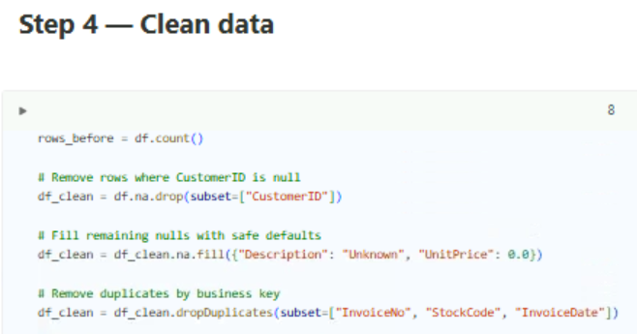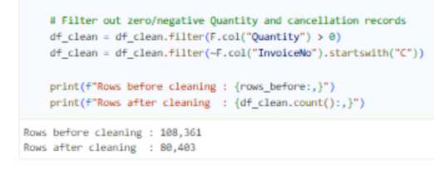
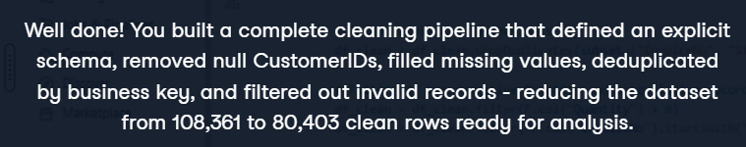

Choosing the right quality metric
A junior engineer at Global Retail Analytics runs the cleaning pipeline on a fresh online_retail upload but accidentally comments out the na.drop(subset=["CustomerID"]) line. The remaining steps - na.fill(), dropDuplicates(), and the invalid-record filter - all run without errors.
Which quality check metric would immediately reveal the mistake? R: The null rate for CustomerID would be above zero instead of the expected 0.00%.
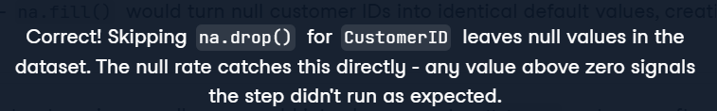

Joining and aggregating retail data
Your team at Global Retail Analytics wants to understand revenue patterns across regions. A new CSV file called country_lookup.csv has been added to the datasets volume, mapping each country to its region and currency.
You'll enrich the online_retail data with this lookup dataset using a broadcast join, verify the query plan, and aggregate revenue by region.
- Open the ex_2_2 notebook and replace the volume paths with your catalog name.
- Complete the broadcast join on Country to enrich the data with region and currency from the lookup dataset.
- Verify the query plan to confirm Spark used a broadcast join instead of a shuffle.
- Complete the aggregation to calculate total revenue and order count per region.
- Which region has the highest total revenue? R: Europe

Step1: Load de data
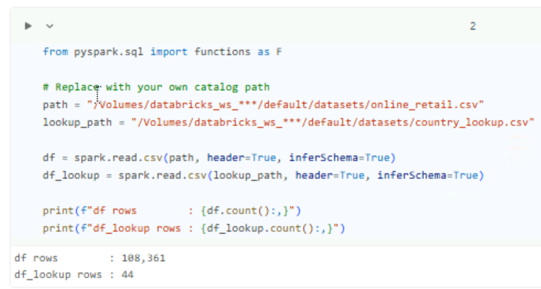
Step 2: Broadcast join with lookup table
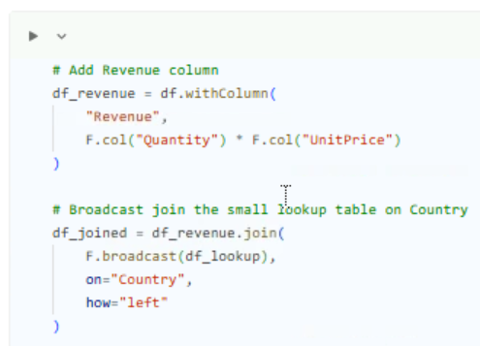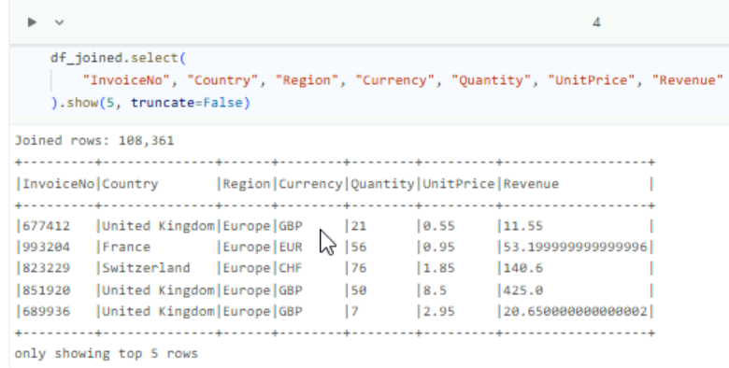
Step3: Verify the query plan
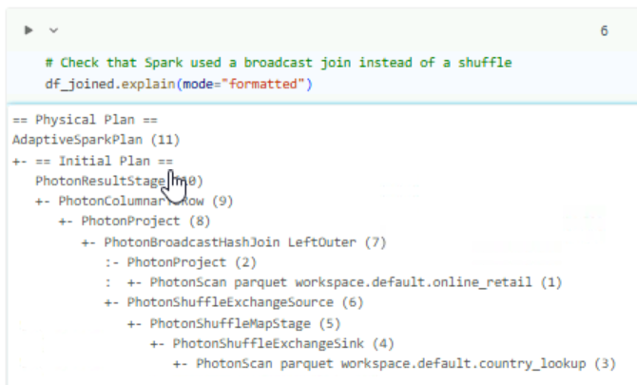
Step 4: Revenue by region
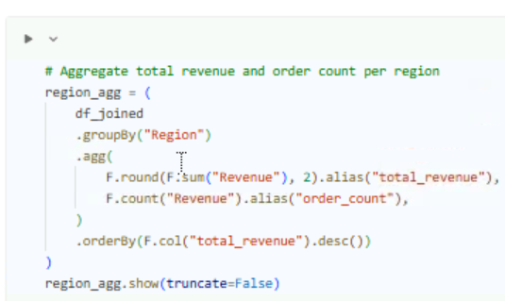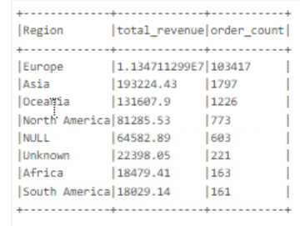

Understanding the shuffle bottleneck
Your manager at Global Retail Analytics asks you to enrich the online_retail dataset (over 100,000 rows) with region data from country_lookup (44 rows). You write a standard left join, but the query takes several minutes. A senior engineer checks your .explain() output, spots ShuffleExchange nodes, and tells you: "The shuffle is your bottleneck."
What does the senior engineer mean by "the shuffle"? R: Spark is moving rows across the network between machines so that rows with matching join keys end up together.


When to use a broadcast join
Now that you know shuffle is the bottleneck, your team at Global Retail Analytics wants to fix a slow query. It joins a sales_transactions table (50 million rows) with a product_categories table (2,000 rows) using a standard left join, and it runs for over ten minutes. You suggest switching to a broadcast join using F.broadcast().
Why would a broadcast join speed up this query? R:
Spark is moving rows across the network between machines so that rows with matching join keys end up together.


Chapter 3 – Analytics and Production Pipelines
Ranking customers with window functions
Your manager at Global Retail Analytics wants to know which customers drive the most revenue. The online_retail dataset is already loaded into a Unity Catalog volume.
Use window functions to rank customers by total spending and find the top performers.
- Open the ex_3_1 notebook and replace the volume path with your catalog name.
- Complete the revenue calculation to compute total revenue per customer.
- Complete the ranking to find the top customers by revenue.
- Which CustomerID has the highest total revenue? R: 15516
Step1 Upload and load data
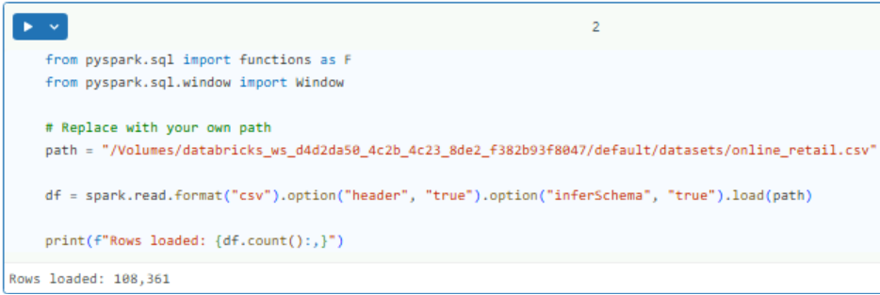

Step 2 Calculate revenue per costumer
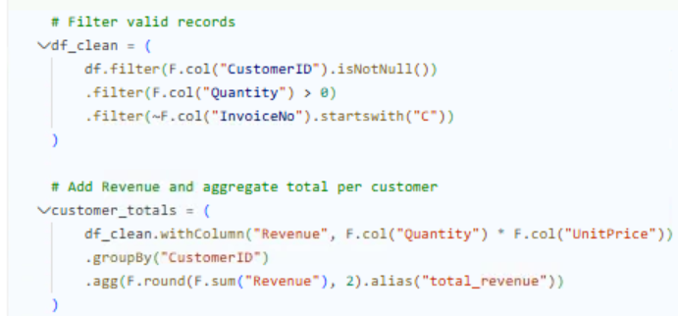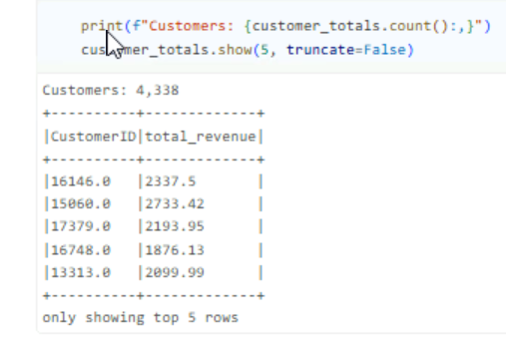
Step 3 Rank costumers bu total revenue
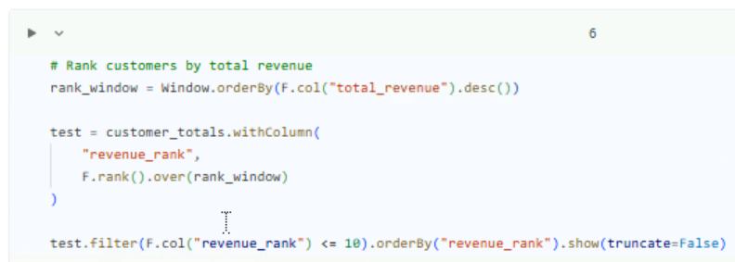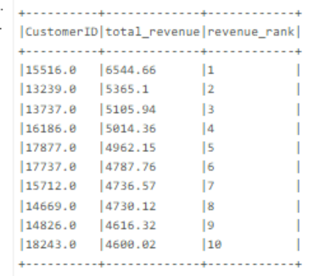

Streaming retail data into Delta Lake
New order files land daily in your team's volume at Global Retail Analytics.
Instead of reloading everything each morning, you'll build a streaming pipeline that picks up new CSV files automatically, writes them to Delta Lake, and recovers gracefully from restarts using checkpoints.
- Open the ex_3_2 notebook and replace the volume paths with your catalog name.
- Complete the streaming reader by specifying the read method and the schema.
- Complete the streaming writer with the checkpoint location.
- Complete the checkpoint recovery step by specifying the Delta output path.
- How many rows were written to Delta Lake after the first stream run? R: 5000
Step1 Prepare stream files
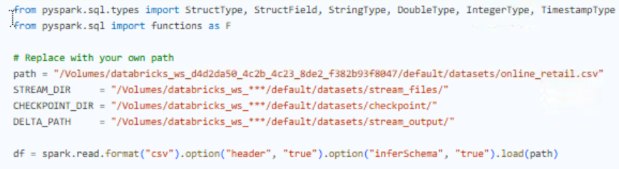
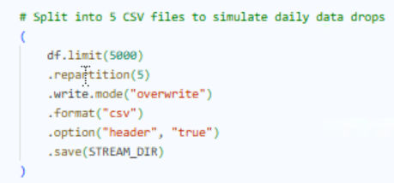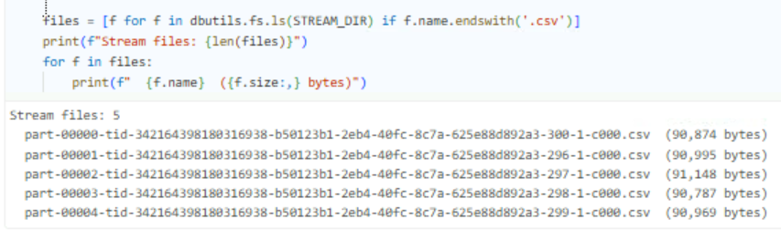
Step2 Define Schema and read streams
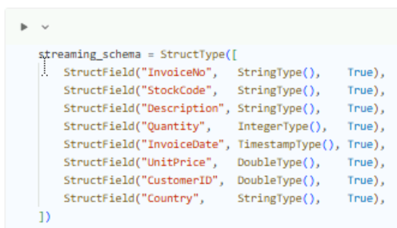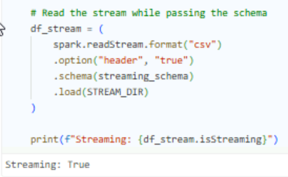
Step3 write to Delta with checkpoint
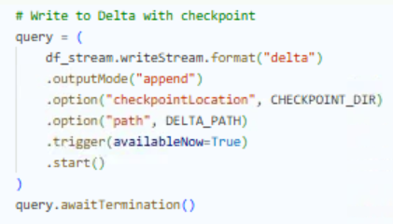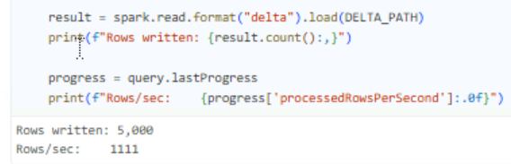
Step 4 Checkpoint recovery
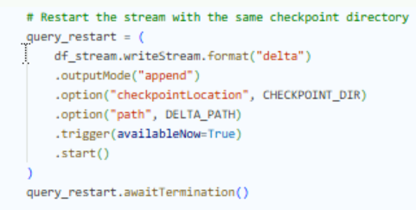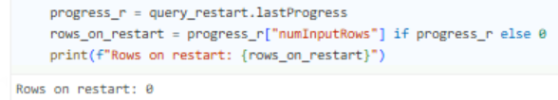

Resuming after a restart
Your streaming pipeline at Global Retail Analytics picks up new CSV files from a Unity Catalog volume and writes them to Delta Lake. After a weekend outage, the cluster restarts on Monday morning. Three new files landed over the weekend. The stream processes only those three files — none of the files from the previous week are reloaded.
What allows the stream to skip previously processed files and resume exactly where it left off? R: The checkpoint directory stores metadata about which which files have been processed

Writing and reading a Delta table
Your team at Global Retail Analytics needs a reliable way to persist cleaned data between sessions. Right now, everything lives in memory and disappears when the cluster shuts down.
Use Delta Lake to save the cleaned retail data as a managed table and read it back through Unity Catalog.
- Open the ex_3_3 notebook and replace the volume path with your catalog name.
- Complete the write step to save the cleaned DataFrame as a Delta table
- Read the Delta table back and verify the row count matches.
- Why is saving data as a Delta table more reliable than keeping it as a CSV file? R: ACID transactions ensure failed writes are rolled back automatically

Step 1 Load and clean data
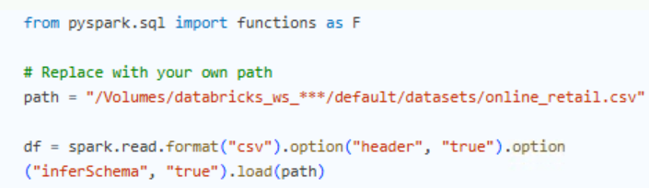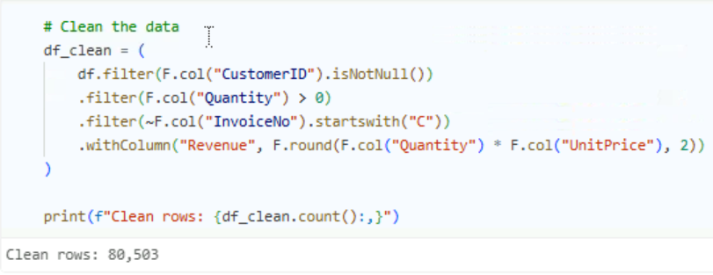
Step 2 Write to Delta
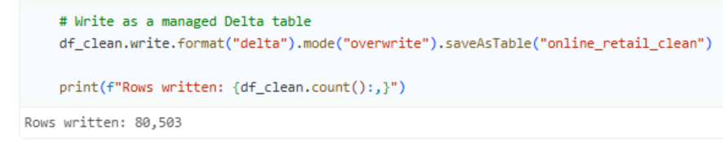
Step3 Read back and verify
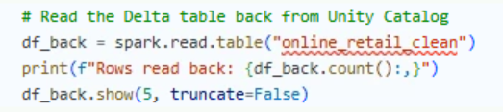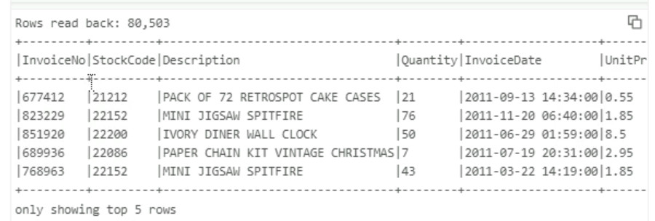

Building a multi-task job pipeline
Your team at Global Retail Analytics has split the data pipeline into three notebooks: task1_ingest cleans the raw CSV and writes a Delta table, task2_revenue aggregates revenue by country, and task3_top_customers ranks customers by spend. All three are preloaded in the Exercises folder.
Your job is to wire them into a Databricks Job, run the pipeline, and fix any errors that come up.
- Open the three task notebooks and update the volume path in task1_ingest with your catalog name.
- Create a new job in Jobs and Pipelines and add all three notebooks as tasks with the correct dependencies.
- Run the job. When a task fails, open the notebook, fix the error, and rerun.
- Which task failed when you first ran the pipeline? R: task2_revenue
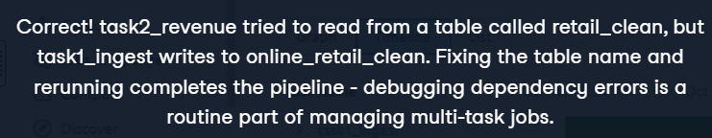
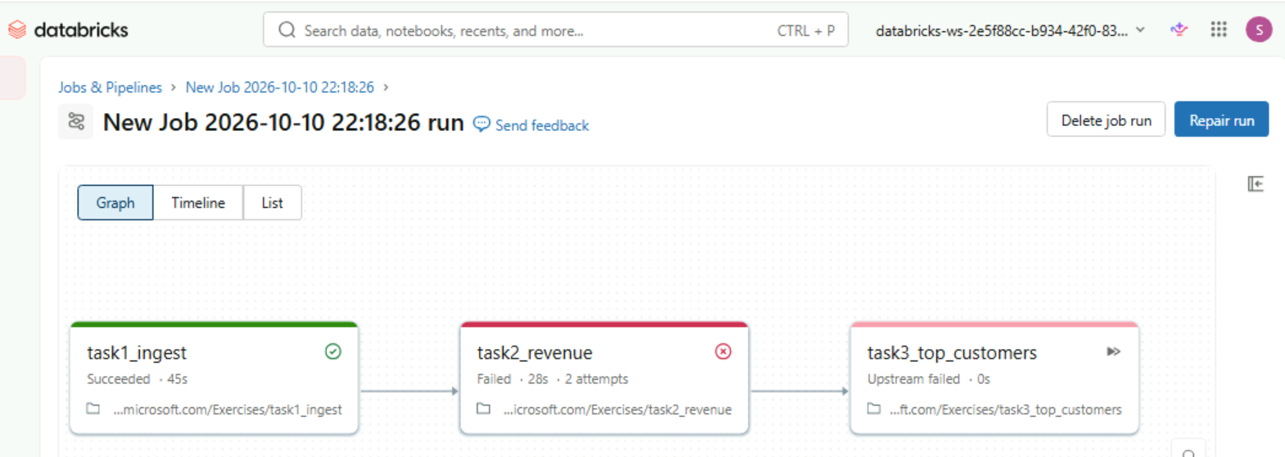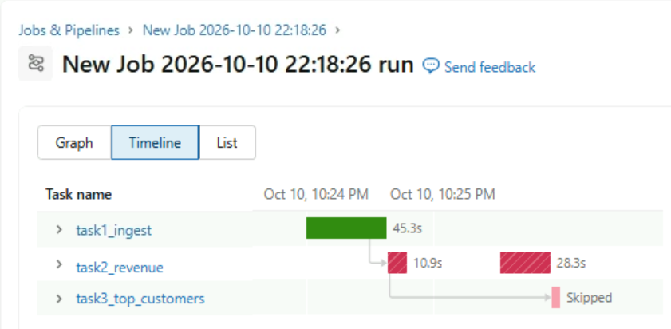
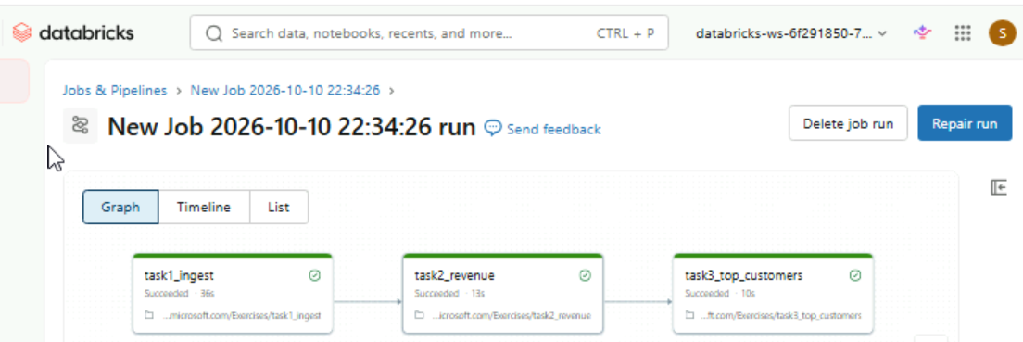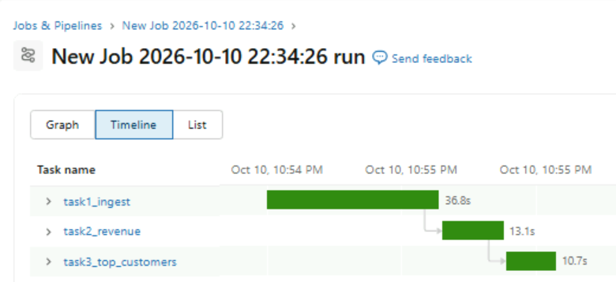

Why switch to Lakeflow?
Your team at Global Retail Analytics maintains a 3-task Databricks Job that ingests, cleans, and aggregates retail data nightly. A senior engineer proposes rewriting the pipeline using the @dlt.table pattern in Lakeflow.
What is the main advantage of switching to Lakeflow for this pipeline? R: You declare what each table should contain, and Databricks figures out the execution order and handles retries automatically.


Final Notes about Databricks system:
Cloud Storage -> Databricks operates on top of the client's cloud storage (such as AWS S3, Azure ADLS, or Google Cloud Storage). It can work with external tables or managed tables, where Databricks and Unity Catalog directly manage the data's location and lifecycle.
Unity Catalog -> Governance layer: The centralized governance layer. It manages access control, auditing, data discovery, and data lineage across all workspaces.
Delta Lake -> Storage Layer: The storage layer that makes data permanent. It transforms flat files in the Data Lake by adding reliability through ACID transactions and version control.
Compute engine and execution -> Compute engine: The distributed processing engines (Apache Spark and Photon) responsible for executing code, running queries, and performing data transformations.
Workspace -> Consumption layer: The collaborative environment where users interact with the data through Notebooks, Databricks SQL, Machine Learning, and Workflows.

